

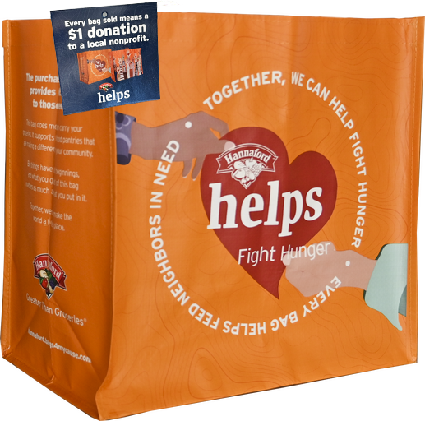

FIGHT HUNGER BAG PROGRAM

Reminder Email

**SUBJECT:** We have *[insert number of weeks or other time frame]* weeks remaining in our Hannaford Fight Hunger Bag Program partnership!

**PREVIEW TEXT:** There’s still time to maximize this opportunity for our cause!

Good morning,

We've reached [*or We will shortly reach*] the halfway point in our [*insert month*] partnership with the Hannaford Fight Hunger Bag Program. This is a wonderful opportunity to raise funds for our organization, spark positive change in our community, and help feed those in need!

Remember, for every $2.50 reusable Hannaford Fight Hunger Bag purchased at [*insert location(s)*] this month, we'll receive $1. Every bag counts, so let's maximize this opportunity!

Please spread the word to your friends and family. Let's encourage everyone to look for the Hannaford Fight Hunger Bags in our selected store(s) this month. There’s still time left to make a difference!

For more information about this impactful program, please visit [hannaford.2givelocal.com](https://hannaford.2givelocal.com/).

Thank you for your support!

Best,

[*Signature*]