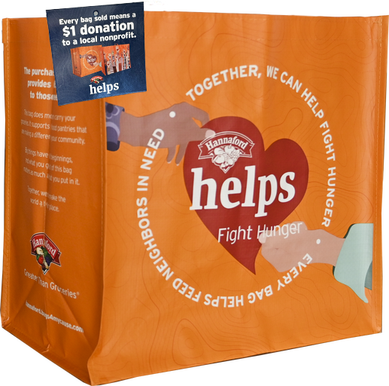



**FIGHT HUNGER BAG PROGRAM**

Announcement Email

& Social Post

**SUBJECT LINE:** We’ve been selected to partner with the Hannaford Fight Hunger Bag Program!

**PREVIEW TEXT:** During [*Month*], we receive $1 for every reusable Fight Hunger Bag purchased at our selected Hannaford location!

Dear [*Staff/Board/Volunteers/Supporters*],

We are excited to share that Hannaford has selected [*organization*] to benefit from the Fight Hunger Bag Program throughout [*month*]. The Hannaford Fight Hunger Bag Program makes it easy for shoppers to contribute to their local communities.

Every time a $2.50 reusable Fight Hunger Bag is purchased at the Hannaford located at [*location*] in [*month*], $1 will be donated to [*organization*]. This is a great way to broaden awareness of our mission and help our cause.

Let’s get started! Share the news with friends and family. Call, send emails, and post on social media. The more people who purchase a Fight Hunger Bag in [*month*], the greater the donation we will receive from Hannaford!

For more information about this program, please visit [hannaford.2givelocal.com](https://hannaford.2givelocal.com/).

Best,

[*Signature*]



**Share With Your Followers**

**We’re excited that Hannaford has selected our organization to benefit from the Fight Hunger Bag Program! Throughout [*month*], we will receive a $1 donation for every $2.50 reusable Fight Hunger Bag purchased at the Hannaford located at [*address of selected store(s)*].**