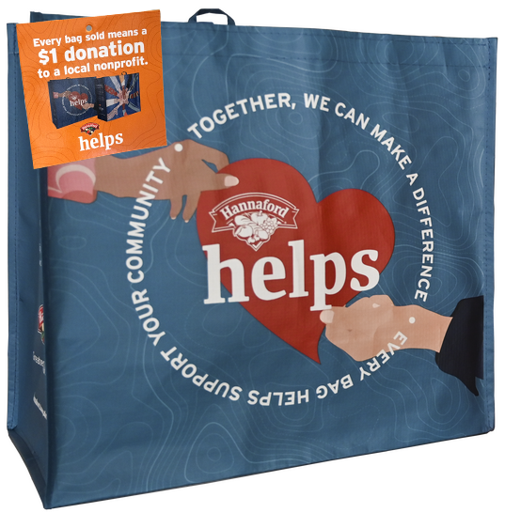



**HANNAFORD COMMUNITY BAG PROGRAM**

Fact Sheet

Congratulations on your organization’s selection in the Hannaford Community Bag Program! The Community Bag is a component of the Hannaford Helps Reusable Bag Program together with the Fight Hunger Bag.

**Not sure how to start talking about the program? We’re here to help!** We’ve brought together key facts and talking points from across the program website compiled in one place. Below you will find information you can use to discuss this program with your board, staff, and supporters:

1. The Hannaford Helps Reusable Bag Program has been operating since April 2014 when the first Fight Hunger Bag was sold. The first Community Bag was sold in October 2015.
2. Since inception, the program has donated $3,590,373 to 6,517 nonprofit organizations and sold 4,257,419 reusable bags.*
3. Hannaford operates 220 stores across Maine, Massachusetts, New Hampshire, Vermont, and New York that participate in the program.
4. The Hannaford Community Bag Program makes it easy for shoppers to support their communities and environment by buying durable, reusable shopping bags. A portion of each purchase goes to a local nonprofit organization. The Community Bag benefits civic, education, health & wellness, and military/veterans organizations.
5. Every month, the Store Leadership Team at each Hannaford location chooses a local nonprofit organization to be the monthlong beneficiary of the Community Bag. Different nonprofits are selected every month to ensure the many organizations making a difference in our local communities can be supported by this program. The name of the organization is displayed on the reusable bag rack during their benefiting month.

________________________________________

*\*As of 5.12.2025. These statistics are updated regularly on the program website and can be found* [***here***](https://hannaford.2givelocal.com/program/hannaford-helps-reusable-bag/)*. You will want to use the most recent stats available at the time of your selection.*

**Page 2**

1. Generally, the nonprofits selected by a specific store are within a 10-mile radius of that store location. It’s important to note that this program benefits each store’s regional shopping area.
2. Each bag costs $2.50, with $1 of that purchase going to support a benefiting nonprofit in your community.
3. Nonprofits meeting the [**program's qualifications**](https://hannaford.2givelocal.com/submit-your-organization/) are submitted to our database of thoroughly researched organizations within the vicinity of each store location
4. A list of nonprofit organizations that have benefited from the Community Bag Program can be found [**here**](https://hannaford.2givelocal.com/community-impact-by-non-profit/) on the program website and is organized alphabetically.
5. The bags are made from 95% recycled materials from either nonwoven or woven polypropylene. They are manufactured in Vietnam in factories that follow the strictest guidelines for employment and production standards.

*Published 5.12.2025*