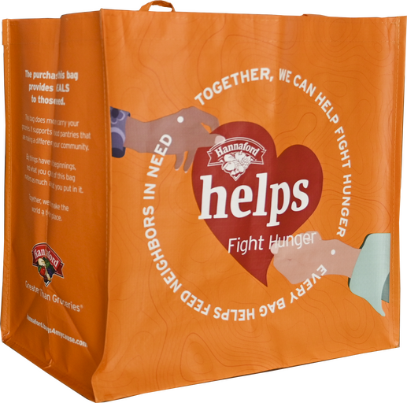

HANNAFORD FIGHT HUNGER BAG PROGRAM

Announcement Email

SUBJECT LINE: We’ve been selected by the Hannaford Fight Hunger Bag Program!

PREVIEW TEXT: For all of [month] every reusable Fight Hunger Bag purchased at Hannaford earns us a $1 donation!

Dear [Staff/Board/Volunteers/Supporters],

We are so excited to share that, for the entire month of [month], [organization] has been selected by store leadership at Hannaford’s [location] to receive a $1 donation from every purchase of the $2.50 Fight Hunger Bag. This is a great way to broaden awareness and help our cause.

The Fight Hunger Bag Program facilitates community support with the goal of making a difference where shoppers live and work.

Let’s get started! Share the news with friends and family. Call, send emails and post on social media. The more people who purchase the Fight Hunger Bag in [month], the greater the donation we will receive from Hannaford!

To learn more about this program, please visit hannaford.2givelocal.com.

Best,

[Signature]

