\

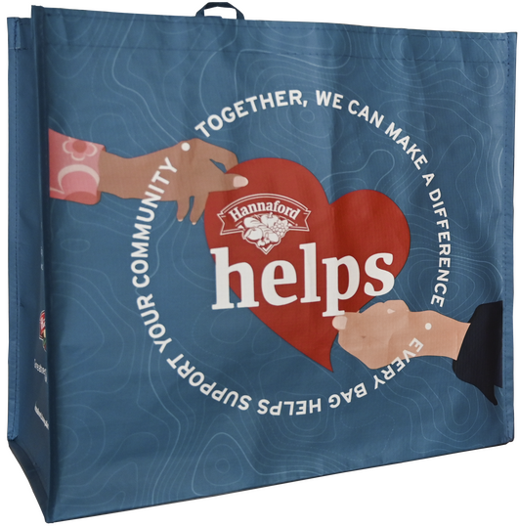



**HANNAFORD COMMUNITY BAG PROGRAM**

Announcement Email

**SUBJECT LINE:** We’ve been selected by the Hannaford Community Bag Program!

**PREVIEW TEXT:** During [m*onth*], we receive $1 for every reusable Community Bag purchased at Hannaford!

Dear [*Staff/Board/Volunteers/Supporters*],

We are so excited to share that, for the entire month of [*month*], [*organization*] has been selected by store leadership at Hannaford’s [*location*] to receive a $1 donation from every purchase of the $2.50 Community Bag. This is a great way to broaden awareness and help our cause.

The Community Bag Program facilitates community support with the goal of making a difference where shoppers live and work.

Let’s get started! Share the news with friends and family. Call, send emails, and post on social media. The more people who purchase the Community Bag in [*month*], the greater the donation we will receive from Hannaford!

To learn more about this program, please visit [hannaford.2givelocal.com.](https://hannaford.2givelocal.com/)

Best, [*Signature*]