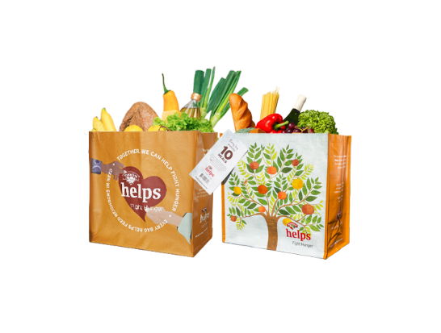



**HANNAFORD FIGHT HUNGER BAG & SNACK PALS PLATES PROGRAMS**

Sample Press Release

**FOR IMMEDIATE RELEASE:** [*Name of organization*] [*Name, phone & email*]

**[*Name of organization*] has been selected as an October Hannaford Fight Hunger Bag and Snack Pals Plates Programs beneficiary.**

[*City, State*] – For the entire month of October, store leadership at Hannaford’s [*location*] location has selected [*Name of organization*] to receive a $1 donation from every purchase of the $2.50 Fight Hunger Bag and $0.25 from every purchase of a Snack Pals Plate, priced 2/$5.

The Fight Hunger Bag Program facilitates community support with the goal of making a difference in the vicinities where shoppers live and work. More than $1 million has been donated to over 1,400 hunger organizations since the Program launched in April 2014.

The Snack Pals Plates Program makes building lifelong eating habits fun while impacting hunger in our local community. Snack Pals Plates are located in special displays in the produce section at the store.

“[*1-2 sentence quote reflecting excitement about being chosen*],” said [*name*], Executive Director of [*name of organization*]. “[*Short quote on how this donation will help you fulfill mission*].”

[*Name of organization*] is a non-profit based in [*city, state*]. Founded in [*year*], [*name of organization*] has [*describe efforts in the community*]. Learn more about [*name of organization*] by visiting [*website*].

For more information on the Hannaford Fight Hunger Bag and Snack Pals Plates Programs, visit [hannaford.2givelocal.com](https://hannaford.2givelocal.com/).

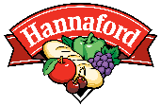

[hannaford.2givelocal.com](https://hannaford.2givelocal.com/)