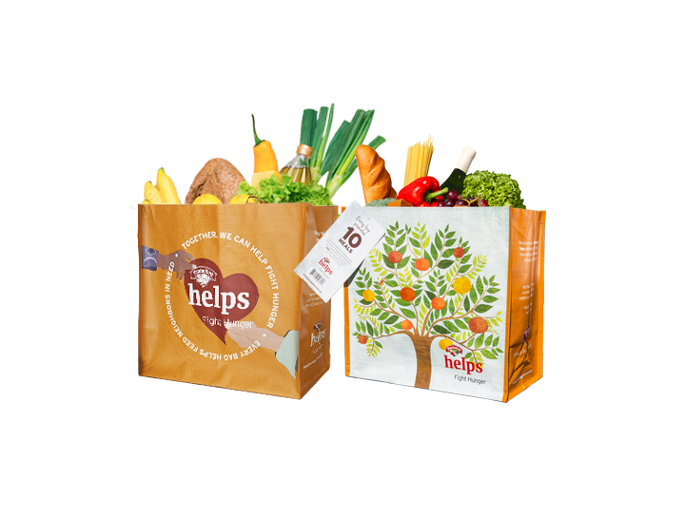
HANNAFORD FIGHT HUNGER BAG PROGRAM

Sample Press Release

DOWNLOAD IMAGES

FOR IMMEDIATE RELEASE: [Name of organization] [Name, phone & email]

[Name of organization] has been selected as [month]’s Hannaford Fight Hunger Bag Program beneficiary.
[City, State] – For the entire month of [month], store leadership at Hannaford’s [location] location has selected [Name of organization] to receive a $1 donation from every purchase of the $2.50 Fight Hunger Bag.
The Fight Hunger Bag Program facilitates community support with the goal to make a difference in the vicinities where shoppers live and work. Almost $1 million has been donated to over 1,400 hunger organizations since the Program launched in April 2014.

“[1-2 sentence quote reflecting excitement about being chosen],” said [name], Executive Director of [name of organization]. “[Short quote on how this donation will help you fulfill mission].”

[Name of organization] is a non-profit based in [city, state]. Founded in [year], [name of organization] has [describe efforts in the community]. Learn more about [name of organization] by visiting [website].

For more information on the Hannaford Fight Hunger Bag Program, visit hannaford.2givelocal.com.

hannaford.2givelocal.com

