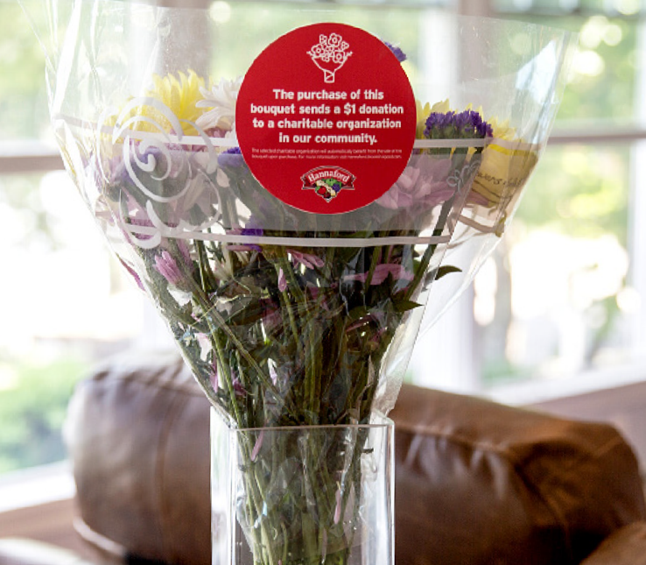

B L OO M I N ’ 4 G OO D P R OG R A M
Sample Press Release

CLICK HERE FOR MARKETING MATERIALS

FOR IMMEDIATE RELEASE: [Name of organization] [Name, phone & email]

[Name of organization] has been selected as March’s Hannaford Bloomin’ 4 Good Program beneficiary

[City, State] – For the entire month of March, [Name of organization] will receive $1 donation from every Bloomin’ 4 Good bouquet with the red circle sticker sold at Hannaford’s [location] location.

The Hannaford Bloomin’ 4 Good Program is an easy way for shoppers to give back to their communities. Every month, leadership at each Hannaford store selects a nonprofit to benefit from the sales of Bloomin’ 4 Good bouquets. Since the Program launched in August 2021, more than 2,000 organizations have received over $160,000 in donations.

“Brighten someone’s day while giving back locally!” said [name], Executive Director of [name of organization]. “Purchasing a Bloomin’ 4 Good Bouquet at [town’s] Hannaford in March will help our organization serve our community better.”

[Name of organization] is a nonprofit based in [city, state]. Founded in [year], [name of organization] has [describe efforts in the community]. Learn more about [name of organization] by visiting [website].

For more information about the Hannaford Bloomin’ 4 Good Program, please visit hannaford.2givelocal.com.

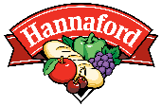
hannaford.2givelocal.com

