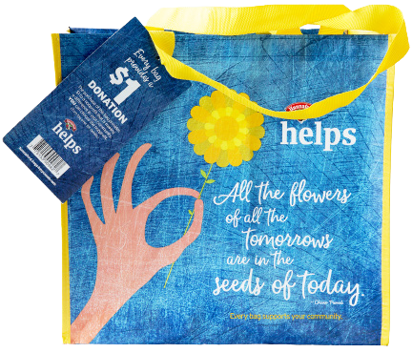
HANNAFORD COMMUNITY BAG PROGRAM

Sample Press Release

DOWNLOAD IMAGES

FOR IMMEDIATE RELEASE: [Name of organization] [Name, phone & email]

[Name of organization] Celebrates Selection as a Hannaford Community Bag Program Beneficiary

[City, State] – [Name of organization] has been selected as a beneficiary of the Hannaford Community Bag Program for the month of [month].

The Hannaford Community Bag Program, which launched in October 2015, is a reusable bag program that facilitates community support with the goal to make a difference in the communities where shoppers live and work.

[Name of organization] was selected as the [month] beneficiary of the program by store leadership at the Hannaford located at [location]. [Name of organization] will receive a $1 donation every time the $2.50 Hannaford Community Bag is purchased at this location during [month], unless otherwise directed by the customer through the Giving Tag attached to the bag.

“[1-2 sentence quote reflecting excitement about being chosen],” said [name], Executive Director of [name of organization]. “[Short quote on how this donation will help you fulfill mission].”

[Name of organization] is a nonprofit based in [city, state]. Founded in [year], [name of organization] has [describe efforts in the community]. Learn more about [name of organization] by visiting [website].

For more information on the Hannaford Community Bag Program, visit hannaford.2givelocal.com.

hannaford.2givelocal.com

