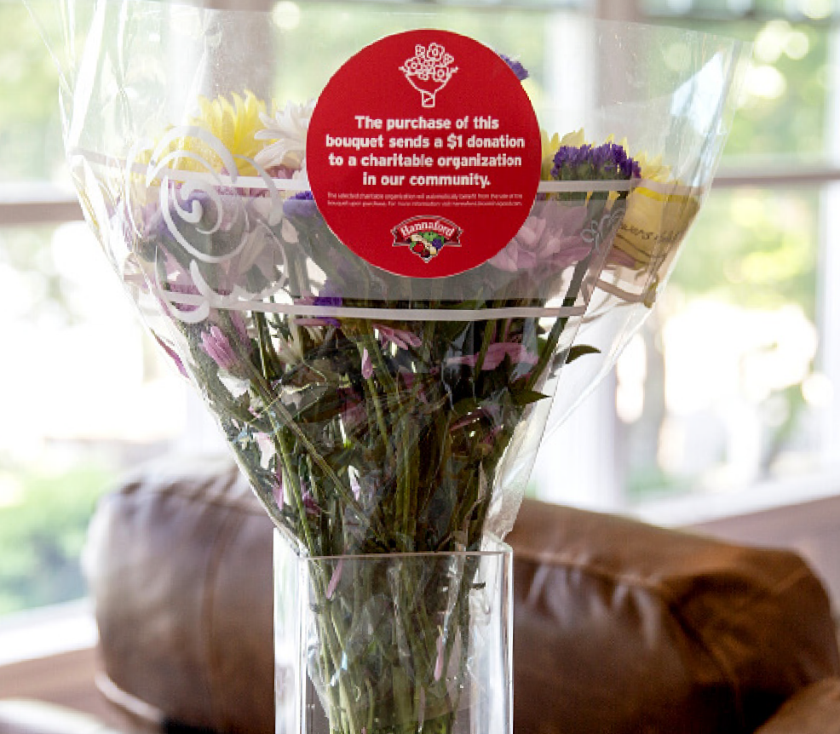

B L OO M I N ’ 4 G OO D P R OG R A M
Sample Press Release

DOWNLOAD IMAGES

FOR IMMEDIATE RELEASE: [Name of organization] [Name, phone & email]

[Name of organization] Celebrates Selection as a Hannaford Bloomin’ 4 Good Program Beneficiary

[City, State] – [Name of organization] has been selected as a beneficiary of the Hannaford Bloomin’ 4 Good Program for the month of [month].

The Hannaford Bloomin’ 4 Good Program, which launched in August 2021, is an easy way for shoppers to give back. Every Bloomin’ 4 Good Bouquet with the red circle sticker sold supports a nonprofit organization local to the Hannaford in which it was purchased.

[Name of organization] was selected as the [month] beneficiary by local store leadership at the Hannaford located at [location]. [Name of organization] will receive a $1 donation for every Bloomin’ 4 Good Bouquet with the red circle sticker purchased at this Hannaford location in [month].

“Flowers can make someone’s day, brighten a room or spread a smile,” said [name], Executive Director of [name of organization]. “Now they can give back to our local communities, too. Purchase a Bloomin’ 4 Good Bouquet at [town] Hannaford in [month] to help our organization support ours better. ”

[Name of organization] is a nonprofit based in [city, state]. Founded in [year], [name of organization] has [describe efforts in the community]. Learn more about [name of organization] by visiting [website].

For more information about the Hannaford Bloomin’ 4 Good Program, please visit hannaford.2givelocal.com.

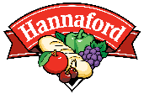
hannaford.2givelocal.com

