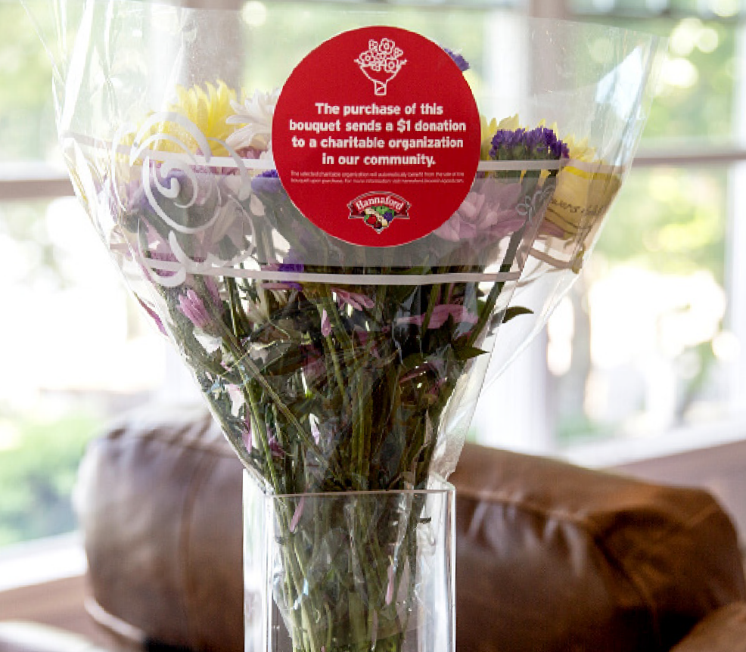

BLOOMIN’4 GOOD PROGRAM
Launch Day Email

DOWNLOAD IMAGES

SUBJECT: Let’s Start Raising Donations TODAY!

It’s GO Time!

Today is the first day of [month], which means it is our first day benefiting in the Hannaford Bloomin’ 4 Good Program! Starting today and for the entire month of [month], our organization will receive a $1 donation for every Bloomin’ 4 Good Bouquet with the red circle sticker purchased at the Hannaford located at [location].

Flowers can make someone’s day, spread smiles and brighten up a room. For this month, they can also help [name of organization] serve someone in need. Why not purchase two, three or even four bouquets this month?

Please help us spread the word in our community! Share this news with family and friends, post on social media, email supporters and get the word out.

A bouquet of flowers is a great gift. This program makes it possible to make someone’s day and support our organization and community at the same time.

The Bloomin’ 4 Good Bouquets with the red circle sticker are located in the floral section of the store. For more information about this program, please visit hannaford.2givelocal.com.

Thank you for your support, [Signature]

hannaford.2givelocal.com

